**Documentation for Ice Cream Day App Design**

**1. Project Overview**

The Ice Cream Day app is designed to provide a fun and user-friendly experience for ordering ice creams. The app was collaboratively designed using Figma, showcasing a seamless user interface for easy navigation and ordering. This documentation outlines the design elements, screens, and collaborative efforts involved in creating the app.

**2. Design Tools Used**

* **Figma**: Collaborative UI/UX design tool.
* **Layers and Components**: Utilized for organizing design elements effectively.

**3. App Screens**

**3.1 Welcome Screen**

* **Title**: "Welcome" – prominently displayed with a decorative banner.
* **Theme**: Ice cream day celebration with vibrant graphics of ice creams.
* **Action**: A button labeled "GO" that navigates the user to the next screen.

**3.2 Ice Cream Menu Screen**

* **Title**: "ORDER HERE"
* **Design Elements**:
  + Ice cream images (e.g., vanilla, butterscotch, strawberry, chocolate).
  + Circular and rectangular placeholders for ice cream graphics.
  + Text labels for each flavor.
* **Interaction**: Users can select their preferred flavor by tapping on the respective image or text.

**3.3 Order Confirmation Screen**

* **Title**: "ORDER PLACED"
* **Visual Elements**:
  + A thank-you message with a decorative graphic element.
  + Background gradient to enhance visual appeal.

**4. Layers and Organization**

* **Android Compact**: Used for designing screens compatible with Android devices.
* **iPhone Status Bars**: Included for alignment and consistency with iOS standards.
* **Elements**:
  + Text layers for instructions and labels.
  + Image layers for ice cream graphics.
  + Buttons and icons for user interaction.

**5. Collaborative Contributions**

* **Team Member Roles**:
  + Added comments and feedback directly within Figma.
  + Enhanced visuals by adding images of ice creams.
  + Adjusted layouts for better usability.

**6. Notes from Collaboration**

* "Add pictures" feedback was incorporated to enhance the visual elements of the app.
* Adjustments were made to ensure alignment and spacing between elements.

**7. Next Steps**

1. Implement the design into a functional app using development tools.
2. Conduct usability testing to gather user feedback.
3. Finalize and publish the app.

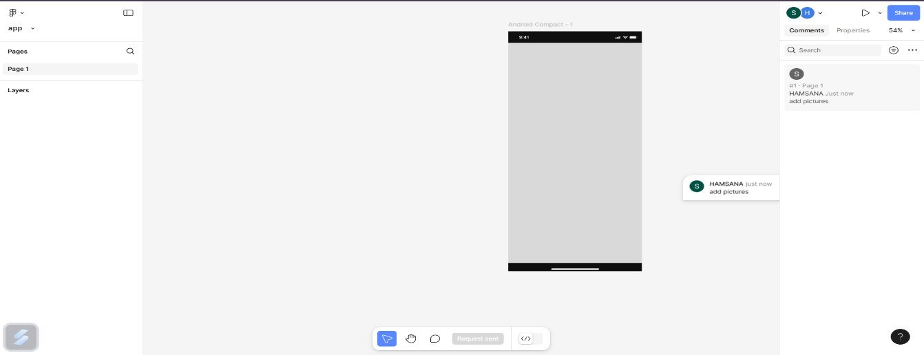

**COLLABORATED**

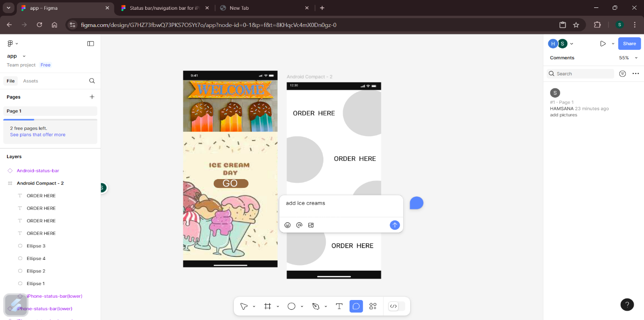

**ADDED COMMENTS**

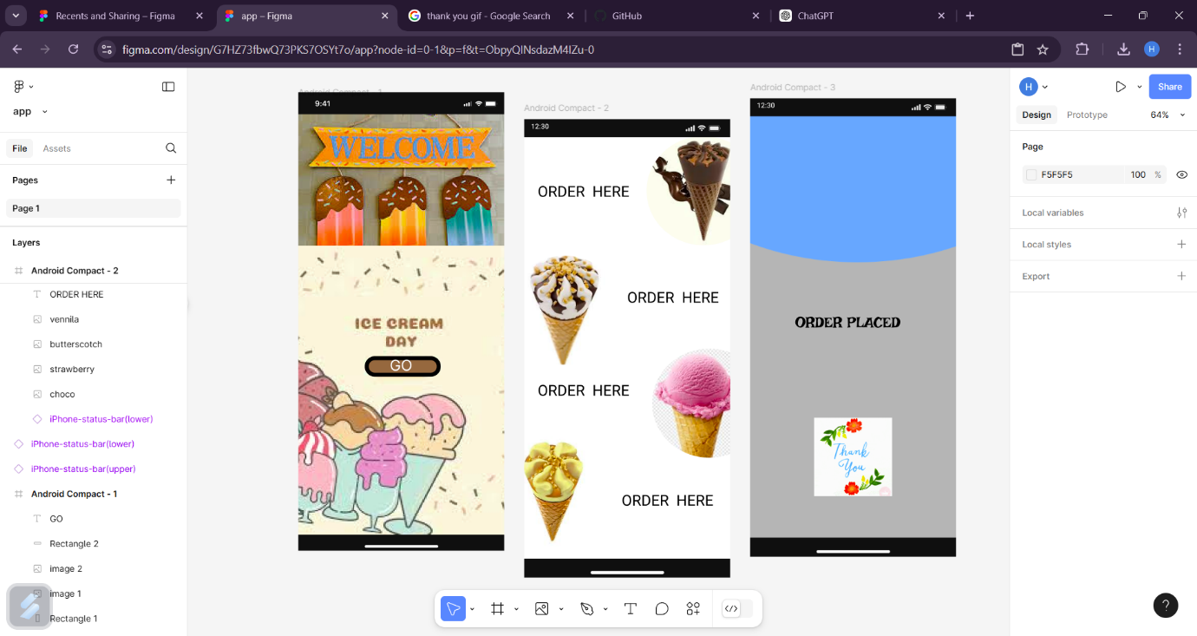

**OVERALL VIEW**